**ABSTRACT**

*Traditionally all CNC stations have been standalone systems i.e. a different setup for every specific operation (milling, drilling, extrusion, etc.) It’s becoming an increasing need to develop integrated systems that can-do multitasking. This is needed primarily due to two major reasons. Space constraints, CNC setups usually take up a huge space for single machining setup. Multiple machining processes require a huge space which becomes impossible for small manufacturing units or educational setups to afford. Cost constraints, Individual CNC setups cost a huge sum of money for different setups for every single operation. For example, a milling setup requires around a INR 1 lakh setup, a drilling setup the same amount, the 3d extrusion setup similar amount. Thus, making it a huge sum. These constraints make the traditional systems unusable for prototyping stages, where it is actually required but is unaffordable. Therefore, it’s becoming a need of the hour to develop multitasking systems, which can not only help in the space and cost constraints but also save the valuable resources.*

**CHAPTER - 1**

**Introduction**

**1.1 Multi tool cnc station**

The Multi Tool CNC Stations are used for performing various tedious manual jobs on a single platform with highest accuracy using CNC computing. Additionally, these systems can be used for small-scale manufacturing.

* 1. **TRADITIONAL PRACTICE**

Traditionally all prototyping was done using standalone systems i.e. a different setup for every specific operation (milling, drilling, extrusion, etc.). This process gets very complicated incase the parameters are to be changed frequently. Also, the availability of all the required tools sometimes becomes an issue.

**1.3** **AIM**

The main aim of the project is to develop a remotely controllable CNC setup that will simplify the prototyping stages and also providing a platform for small-scale manufacturing to the users.

**1.4 OBJECTIVES**

The objectives of the system are-

* To reduce the complexity involved in handling multiple machines.
* To make efficient use of space.
* To improve cost efficiency.
* To conserve resources.

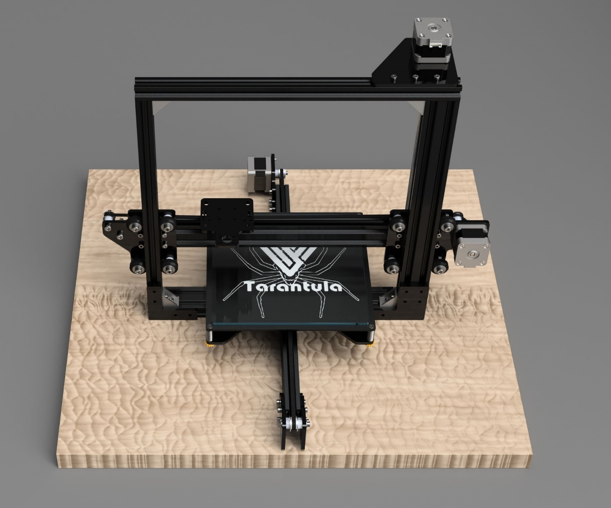

**Fig: 1.1** – **3d printer CAD render.**

**CHAPTER - 2**

**hardware Requirements**

**2.1 Smart LCD Controller**

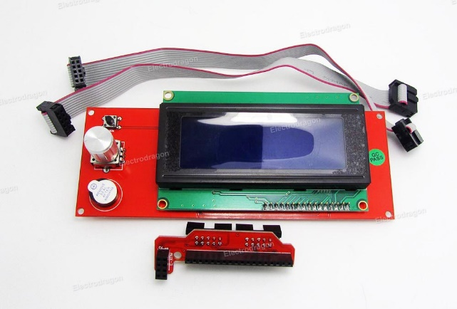

**Fig: 2.1** **– LCD Smart Controller.**

This Smart Controller contains a SD-Card reader, a rotary encoder and a 20 Character x 4 Line LCD display. It can be easily configured to any board using the "smart adapter" included. After connecting this panel to the board there is no need to be connected to a computer all the time. The Smart Controller supplies power for your SD card. Furthermore, all actions like calibration, axes movements can be done by just using the rotary encoder on the Smart Controller. Printing 3D designs without PC, just with a g-code design stored on the SD card can be done using the smart controller.

* 1. **Bowden Extruder**

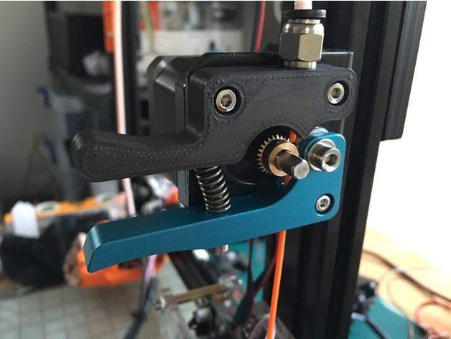

**Fig: 2.2** **-Bowden Extruder**

The Bowden cable reduces the moving mass of the extruder and thus allowing faster controlled motion, less shaking of your machine, less energy use and importantly: faster printing! Normally the mechanism that drives the filament into the hot end (where it melts) is directly on top of the extruder. This creates problems of balance and oscillations with faster motion which can be seen in the printing results and heard and felt when the machine is shaking. If the filament drive mechanism is placed on a non-moving part of the 3D printer, it can be pushed into a tube. PTFE (Teflon™) is useful because it is slippery: it has little friction with the plastic. This limits wear and loss of energy. The tube's other end is connected to the extruder's hot-end.

* 1. **Makerbase MKS GEN V1.4**

MKS Gen is a feature rich all-in-one electronics solution for RepRap and other CNC devices.

It features an onboard ATmega2560. Its five motor outputs are powered by Pololu pin compatible stepper drivers. The board features a developer friendly expansion port supporting giving access the same as Ramps1.4.MKS Gen is designed to be flexible in the user's power source availability, allowing any power supply from 12V-24V.

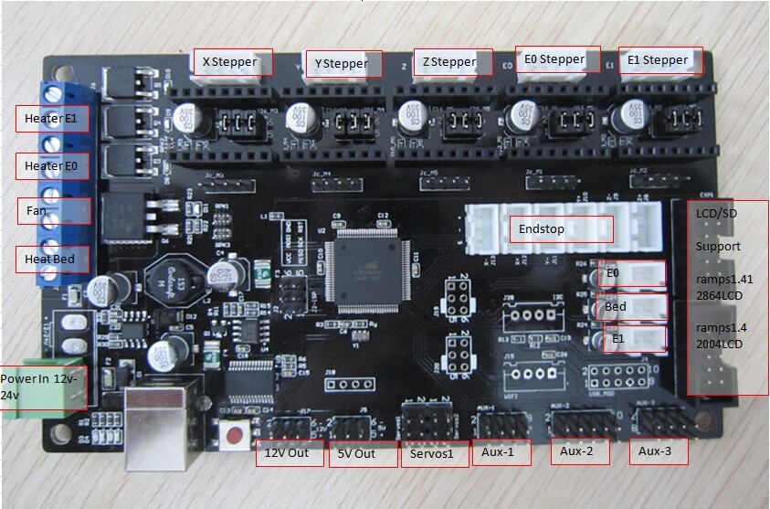

**Fig: 2.3** **– Makerbase MKS GENv1.4.**

**Features**

* Arduino MEGA compatible Atmega2560 and FT232 processors are compatible

with all RAMPS class firmware.

* Firmware can use the same configuration as ramps1.4.
* Easy DISPLAY + SD-CARD connector.
* IEEE standard compatible pin header on board.
* Up to 5 motor drivers with easy micro stepping setup (micro switches).
  1. **Stepper Motor**

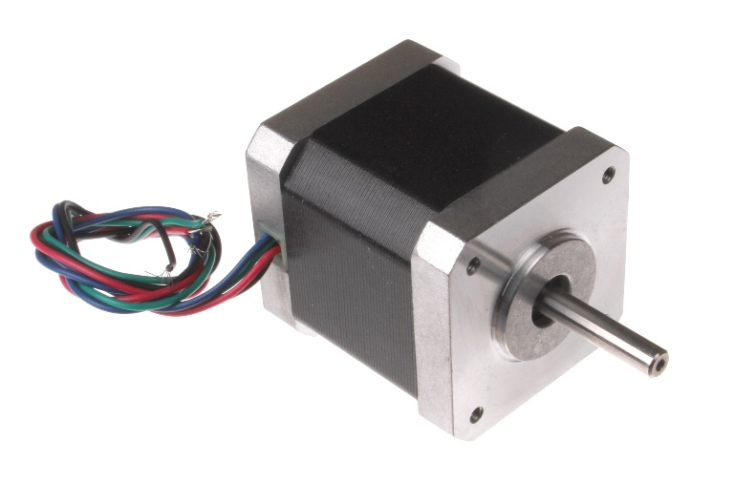

**Fig: 2.4** **– Stepper Motor.**

**Stepper motors** are DC **motors** that move in discrete steps. They have multiple coils that are organized in groups called "phases". By energizing each phase in sequence, the **motor** will rotate, one step at a time. With a computer controlled stepping you can achieve very precise positioning and/or speed control. Servomotors are used in applications such as [robotics](https://en.wikipedia.org/wiki/Robotics), [CNC](https://en.wikipedia.org/wiki/CNC) machinery or automated manufacturing.

* + 1. **Nema 17 Stepper Motor**

**Specifications-**

1. 1.5A to 1.8A current per phase.
2. 1-4 volts.
3. 3 to 8 mH inductance per phase.
4. 44 N·cm (62oz·in, 4.5kg·cm) or more holding torque.
5. 1.8 or 0.9 degrees per step (200/400 steps/rev respectively).
   1. **Raspberry Pi 2 (Model B)**

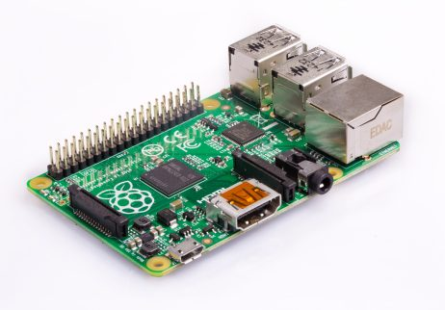

**Fig 2.5 Raspberry pi 2 model B**

Raspberry pi is a single board computer that has all inbuilt peripherals on the board. It can be used at all places where a whole computer cannot be dedicated to a single process.

Technical specifications for the Raspberry pi 2 Model B are as follows: -

* Broadcom BCM2837 Arm7 Quad Core Processor powered Single Board Computer running at 900MHz.
* 1GB RAM.
* 40pin extended GPIO.
* 4 x USB 2 ports.
* 4 pole Stereo output and Composite video port.
* Full size HDMI.
* CSI camera port for connecting the Raspberry Pi camera.
* DSI display port for connecting the Raspberry Pi touch screen display.
* Micro SD port for loading your operating system and storing data.
* Micro USB power source.
  1. **Raspberry Pi Camera Rev1.3**

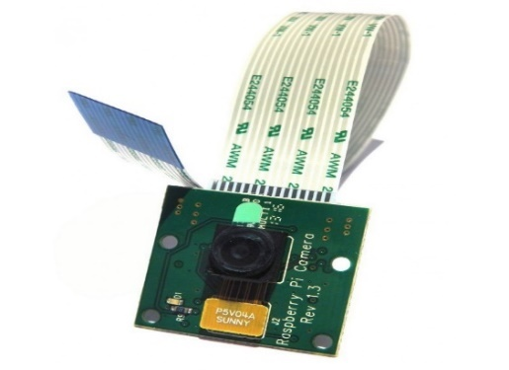

**Fig2.6 Raspberry pi camera**

Custom designed and manufactured by the Raspberry Pi Foundation in the UK, the Raspberry Pi Camera Board features a 5MP (2592×1944 pixels) Omni vision 5647 sensor in a fixed focus module. The module attaches to Raspberry Pi, by way of a 15 Pin Ribbon Cable, to the dedicated 15-pin MIPI Camera Serial Interface (CSI), which was designed especially for interfacing to cameras. The CSI bus is capable of extremely high data rates, and it exclusively carries pixel data to the BCM2835 processor.

* 1. **Wi-Fi adapter**

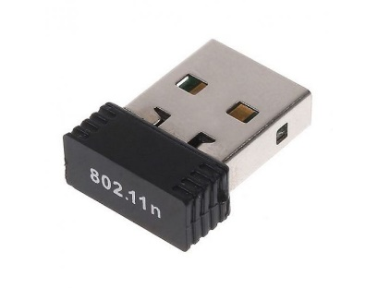

**Fig2.7 Wi-Fi adapter**

**Features-**

1. RT5370 Chipset can provide support for 3D Printer, Raspberry Mother Boards
2. Supporting Operating Systems: WIN2K, XP, VISTA, WIN7, WIN8, WIN10, LINUX.
3. The latest wireless standard: 150 Mbps 802.11n Wireless data rate [Up to 6 times the speed and 3 times the coverage of 802.11b]
4. Supports 64/128-bit WEP, as well as WPA/WPA2 and WPA-PSK/WPA2-PSK encryptions

**CHAPTER - 3**

**SOFTWARE OVERVIEW**

**3.1AutoCAD**

**AutoCAD** is a commercial computer-aided design (CAD) and drafting software application. Developed and marketed by Autodesk, AutoCAD was first released in December 1982 as a desktop app running on microcomputers with internal graphics controllers. Prior to the introduction of AutoCAD, most commercial CAD programs ran on mainframe computers or minicomputers, with each CAD operator (user) working at a separate graphics terminal.

**3.2Slic3r**

Slic3r is the tool needed to convert a 3D model into printing instructions for your 3D printer. It cuts the model into horizontal slices (layers), generates toolpaths to fill them and calculates the amount of material to be extruded.

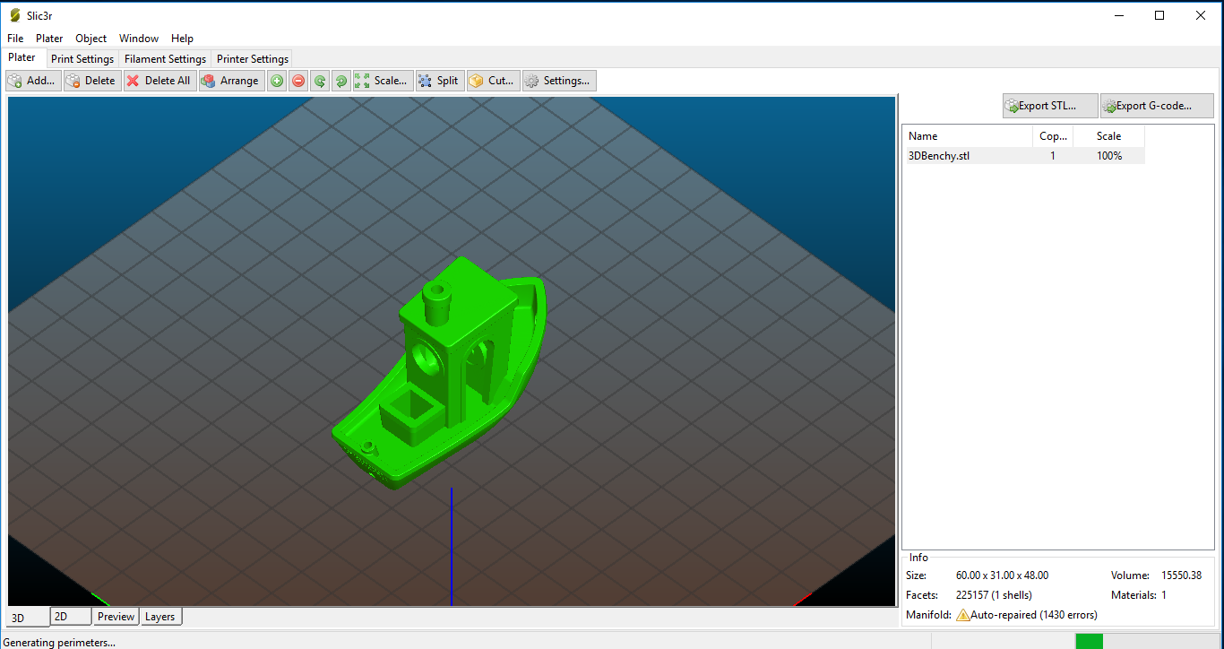

**Fig3.1 Slic3r User Interface**

The Slic3r project was born in 2011 within the RepRap community as an effort to provide the growing 3D printing technology with an open and flexible toolchain. The code and the algorithms are not based on any other previous work. Readability and maintainability of the code are among the design goals. Slic3r allows users to experiment with several original new features such as multiple extruders, brim, micro layering, bridge detection, command line slicing, variable layer heights, sequential printing (one object at time), honeycomb infill, mesh cutting, object splitting into parts, AMF support, avoid crossing perimeters, distinct extrusion widths, modifiers, and much more.

**3.3Inkscape**

**Inkscape** is a free and open-source vector graphics editor; it can be used to create or edit vector graphics such as illustrations, diagrams, line arts, charts, logos and complex paintings. Inkscape's primary vector graphics format is Scalable Vector Graphics (SVG), however many other formats can be imported and exported.

Inkscape can render primitive vector shapes (e.g. rectangles, ellipses, polygons, arcs, spirals, stars and 3D boxes) and text. These objects may be filled with solid colors, patterns, radial or linear color gradients and their borders may be stroked, both with adjustable transparency. Embedding and optional tracing of raster graphics is also supported, enabling the editor to create vector graphics from photos and other raster sources. Created shapes can be further manipulated with transformations, such as moving, rotating, scaling and skewing.

**3.4Arduino IDE**

****The Arduino project provides the Arduino integrated development environment (IDE), which is a cross-platform application written in the programming language Java. It originated from the IDE for the languages Processing and Wiring. It includes a code editor with features such as text cutting and pasting, searching and replacing text, automatic indenting, brace matching, and syntax highlighting, and provides simple one*-*click mechanisms to compile and upload programs to an Arduino board. It also contains a message area, a text console, a toolbar with buttons for common functions and a hierarchy of operation menus.

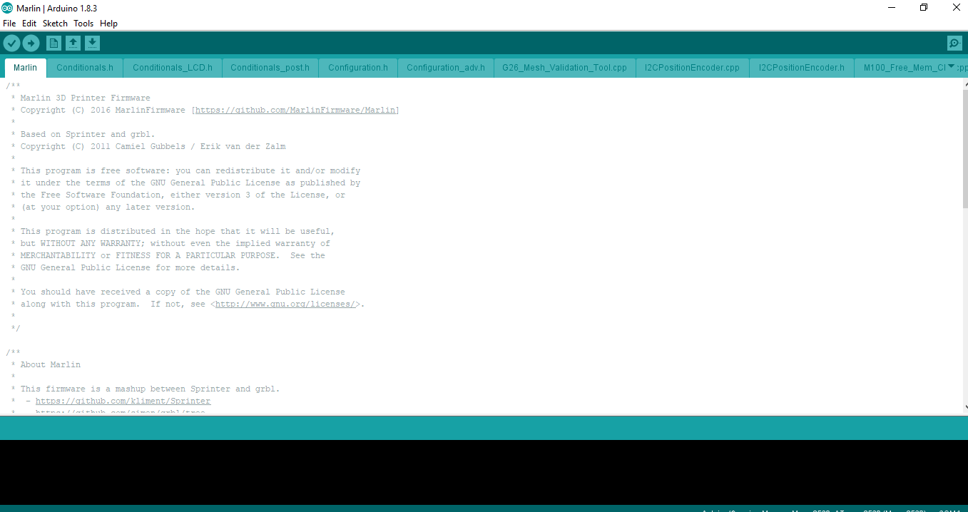

**Fig3.2 Arduino IDE User Interface**

A program written with the IDE for Arduino is called a sketch. Sketches are saved on the development computer as text files with the file extension *.*ino. Arduino Software (IDE) pre-1.0 saved sketches with the extension *.*pde.

**CHAPTER - 4**

**BLOCK DIAGRAM & DESCRIPTION**

**4.1 Block Diagram:**

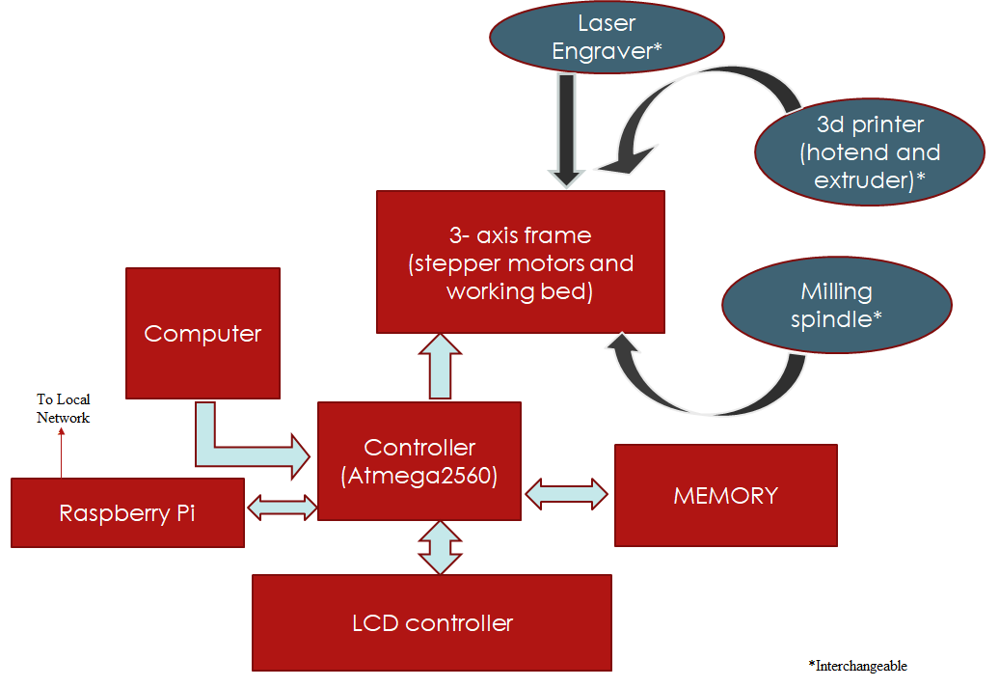

**Fig: 4.1** **– Block diagram.**

**4.2 Block Diagram Description:**

The multi tool setup consists of a modular head which helps in easily interchanging the modular tools specifically designed for the setup. The modular carriage is mounted on a 3-axis (cartesian) moving setup using NEMA 17 bipolar stepper motors. The whole setup is controlled using MKS GENv1.4 board. This is a general-purpose breakout board which is specially designed for 3d printers but can be configured for other applications too. A computer may or may not be connected to the setup. A computer can be used to directly print and monitor jobs although the setup can work even in the absence of a computer. A single board computer (raspberry pi) is used to provide the setup with its own computer rather than dedicating a laptop or pc for the job. Also, the raspberry pi can be connected to the local network for remoted control. The jobs can be monitored using the camera connected to the raspberry pi. The setup also has a smart LCD controller to control the system in real time.

**CHAPTER - 5**

**METHODOLOGY**

**Fig: 5.1 – Flow of the system.**

**CHAPTER - 6**

**PROJECT DESIGN**

Creating 3D object using CAD software

Convert AutoCAD file format into 3D printer compatible format

Get the printed object

Run .stl file using Marline OS

Set the heated bed temperature

Set the extruder temperature according to filament selection

Alline all the three axis X, Y & Z to home position

Turn on the 3D printer

**Fig: 6.1** **– Project Design flow.**

**CHAPTER - 7**

**APPLICATIONS**

**7.1 Applications**

1. Prototyping- Prototyping involves continuously varying various parameters before actually deploying a product. Visiting to manufacturing shops for these small changes may become tiresome as well as costly. A multi tool desktop CNC station will be of most importance in this case
2. Small Scale Manufacturing- Products with least or no reproducibility can be custom designed according to the requirement.
3. Hobby Projects- Hobby projects require custom parts according to the need and also need occasional tweaking. This multi tool CNC station can be very useful for the purpose.

**CHAPTER - 8**

**ADVANTAGES AND DISADVANTAGES**

**8.1 ADVANTAGES:**

1. Can perform multiple operations on the same setup, for example, 3D printing, milling etc.
2. Space requirement is less
3. Suitable for small manufacturer or educational setup
4. Remote monitoring and control making it unnecessary to have an attendant to continuously monitor the job.

**8.2 DISADVANTAGES:**

1. Skilled labors may face unemployment.
2. Modularity may decrease the precision.
3. FDM printing is slow.

**CHAPTER - 9**

**CONCLUSION**

1. There is no need for purchasing and maintaining multiple CNC setups
2. The space constraints of any type will be eliminated
3. The user can reliably perform following operations:
4. 3d printing
5. Vertical Milling
6. Laser Engraving.

**CHAPTER - 10**

**FUTURE SCOPE**

1. The future of Multi tool CNC stations is that these systems can be installed in the various locations such as schools, colleges, various institutes also in industries for prototyping and small-scale manufacturing.
2. These systems can be mass manufactured and can provide a market ready product.

**CHAPTER - 11**

**BIBLIOGRAPHY**

**REFRENCES:**

1. Cheng-Tiao Hsieh *,“Development of an integrated system of 3D printer and laser carving” ,* Published in Microsystems, Packaging, Assembly and Circuits Technology Conference (IMPACT), 2016 11th International, 10.1109/IMPACT.2016.7800062
2. E. Canessa, C. Fonda, and M. Zennaro, “*Low-cost 3D Printing for Science, Education and Sustainable Development”,* International Centre for Theoretical Physics, 2013
3. “*THE THIRD DIMENSION OF PRINTING TECHNOLOGY USING 3DIMENTIONAL MODEL*”, by Dr. Bobby Lukose International Journal of Innovations in Scientific and Engineering Research(IJISER), ISSN:2347-971X, July 2016